Quiz
EV3 Get Moving
Name:_________________________ Period:___ Date:________ Score:_____/55

- (5 pts) List and describe each of the five ways the Duration of a Move Steering block can be set.
- (2 pts) What is the difference between the Brake and Coast settings in a Move Steering Block’s Next Action?
- (5 pts) If Ziffle’s Tribot travels 15cm with a duration setting of 500 degree, what duration setting should be used to have the Tribot travel 50cm?

- (4 pts) Describe how a tribot would behave with this program (include 4 facts):
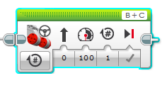
- (4 pts) Describe how a tribot would behave with this program (include 4 facts):
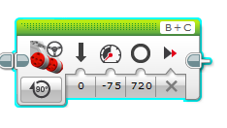
- (4 pts) Describe how a tribot would behave with this program (include 4 facts):
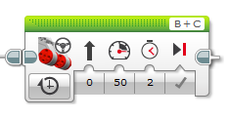
- (4 pts) Describe how a tribot would behave with this program:
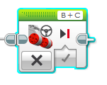
- (3 pts.)What is a threshold?
- (3 pts.)Why must some thresholds be calculated rather than measured?
- (3 pts.)Your Color sensor is reading a value of 16 in an environment where 8 was considered dark and 26 was considered light. Will your robot recognize the present reading of 16 as light or dark? Why?

- (3 pts.)If a motor in a two-gear tribot is attached to an 8 tooth driving gear, and the wheel is attached to a 24 tooth driven gear, what is the gear ratio? Is this an example of gearing up or gearing down?
- (3 pts.)When might you want to gear up your robot? Give an example.
- (3 pts.)When might you want to gear down your robot? Give an example.
- (3 pts.)The program below has a tribot move on the floor and stop on a line. Is the floor dark or light? If the line registers as 60 on the color sensor, what is the reading over the floor?
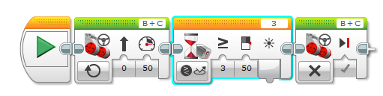

- (3 pts.)Ziffle writes a tribot program that will wait for the lights in the room to be turned off, then say “Good bye” and drive backward into its corner of the room for 15 seconds. Upon trying the program, Ziffle is disappointed to learn that the tribot’s parting words are hard to hear. What two changes to the Sound block could Ziffle make that would allow the tribot to be better heard?
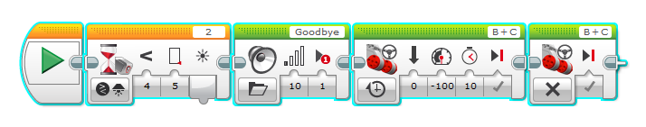
- (3 pts.)Ziffle then writes a program that will wait for the lights in the room to turn back on and have the tribot drive forward out of its corner in the room and stop as soon as the lights turn off. Ziffle sets the light threshold correctly, but once again is surprised and disappointed by the results. What happens when Ziffle tries the program? What needs to be changed to get the desired results?
